Supplementary material

Early non-invasive ventilation for the management of patients with acute respiratory failure: a systematic review and meta-analysis

Supplementary material 1. Search strings.
1. Search string—PubMed (618 results until 04 September 2025)
(“Noninvasive Ventilation” [Mesh] OR “Continuous Positive Airway Pressure” [Mesh] OR “non invasive ventilation” OR “NIV” OR CPAP OR “Continuous Positive Airway Pressure”) AND (“Respiratory Insufficiency” [Mesh] OR “Pulmonary disease, Chronic obstructive” [Mesh] OR “Heart Failure” [Mesh] OR “Pulmonary Edema” [Mesh] OR “Asthma” [Mesh] OR “acute lung injury” [ti]) AND (“Emergency medical services” [Mesh] OR prehospital OR pre-hospital OR out of hospital OR EMS OR wards [tiab] OR ward [tiab])
2. Search String—EMBASE (149 results until 04 September 2025)
(“noninvasive ventilation”:ti,ab OR niv:ti,ab OR cpap:ti,ab OR “continuous positive airway pressure”:ti,ab) AND (“respiratory insufficiency”:ti,ab OR “respiratory failure”:ti,ab OR “chronic obstructive lung disease”:ti,ab OR “heart failure”:ti,ab OR “pulmonary edema”:ti,ab OR “asthma”:ti,ab) AND (“emergency medical service”:ti,ab OR prehospital:ti,ab OR “pre-hospital”:ti,ab OR “out of hospital”:ti,ab OR ems:ti,ab OR ward:ti,ab) AND [english]/lim AND [embase]/lim NOT (“conference abstract”/it OR “conference paper”/it OR “conference review”/it) NOT (([animal cell]/lim OR [animal experiment]/lim OR [animal model]/lim OR [animal tissue]/lim) NOT [humans]/lim) AND (“article”/it OR “article in press”/it)

Supplementary Table 1. PRISMA checklist.
Section and Topic | Item# | Checklist item | Location where item is reported
Title
Title | 1 | Identify the report as a systematic review. | Pag. 1
Abstract
Abstract | 2 | See the PRISMA 2020 for Abstracts checklist. | Pag. 3
Introduction
Rationale | 3 | Describe the rationale for the review in the context of existing knowledge. | Pag. 4
Objectives | 4 | Provide an explicit statement of the objective(s) or question(s) the review addresses. | Pag. 4
Methods
Eligibility criteria | 5 | Specify the inclusion and exclusion criteria for the review and how studies were grouped for the syntheses. | Pag. 6
Information sources | 6 | Specify all databases, registers, websites, organisations, reference lists and other sources searched or consulted to identify studies. Specify the date when each source was last searched or consulted. | Pag. 6
Search strategy | 7 | Present the full search strategies for all databases, registers and websites, including any filters and limits used. | Pag. 6
Selection process | 8 | Specify the methods used to decide whether a study met the inclusion criteria of the review, including how many reviewers screened each record and each report retrieved, whether they worked independently, and if applicable, details of automation tools used in the process. | Pag. 6
Data collection process | 9 | Specify the methods used to collect data from reports, including how many reviewers collected data from each report, whether they worked independently, any processes for obtaining or confirming data from study investigators, and if applicable, details of automation tools used in the process. | Pag. 6
Data items | 10a | List and define all outcomes for which data were sought. Specify whether all results that were compatible with each outcome domain in each study were sought (e.g., for all measures, time points, analyses), and if not, the methods used to decide which results to collect. | Pag. 7
Data items | 10b | List and define all other variables for which data were sought (e.g., participant and intervention characteristics, funding sources). Describe any assumptions made about any missing or unclear information. | Pag. 6
Study risk of bias assessment | 11 | Specify the methods used to assess risk of bias in the included studies, including details of the tool(s) used, how many reviewers assessed each study and whether they worked independently, and if applicable, details of automation tools used in the process. | Pag. 7
Effect measures | 12 | Specify for each outcome the effect measure(s) (e.g., risk ratio, mean difference) used in the synthesis or presentation of results. | Pag. 8
Synthesis methods | 13a | Describe the processes used to decide which studies were eligible for each synthesis (e.g., tabulating the study intervention characteristics and comparing against the planned groups for each synthesis (item #5)). | Pag. 8
Synthesis methods | 13b | Describe any methods required to prepare the data for presentation or synthesis, such as handling of missing summary statistics, or data conversions. | Pag. 8
Synthesis methods | 13c | Describe any methods used to tabulate or visually display results of individual studies and syntheses. | Pag. 8
Synthesis methods | 13d | Describe any methods used to synthesize results and provide a rationale for the choice(s). If meta-analysis was performed, describe the model(s), method(s) to identify the presence and extent of statistical heterogeneity, and software package(s) used. | Pag. 8
Synthesis methods | 13e | Describe any methods used to explore possible causes of heterogeneity among study results (e.g., subgroup analysis, meta-regression). | Pag. 8
Synthesis methods | 13f | Describe any sensitivity analyses conducted to assess robustness of the synthesized results. | Pag. 7
Reporting bias assessment | 14 | Describe any methods used to assess risk of bias due to missing results in a synthesis (arising from reporting biases). | Pag. 7
Certainty assessment | 15 | Describe any methods used to assess certainty (or confidence) in the body of evidence for an outcome. | Pag. 7
Results
Study selection | 16a | Describe the results of the search and selection process, from the number of records identified in the search to the number of studies included in the review, ideally using a flow diagram. | Pag. 9 + Fig. 1
Study selection | 16b | Cite studies that might appear to meet the inclusion criteria, but which were excluded, and explain why they were excluded. | Supplementary Table 2
Study characteristics | 17 | Cite each included study and present its characteristics. | Pag. 9 + Table 1
Risk of bias in studies | 18 | Present assessments of risk of bias for each included study. | Pag. 10 + Supplementary Fig. 1
Results of individual studies | 19 | For all outcomes, present, for each study: (a) summary statistics for each group (where appropriate) and (b) an effect estimate and its precision (e.g., confidence/credible interval), ideally using structured tables or plots. | Pag. 10–12 + Table 2
Results of syntheses | 20a | For each synthesis, briefly summarise the characteristics and risk of bias among contributing studies. | Pag. 10–12 + Supplementary Fig. 1
Results of syntheses | 20b | Present results of all statistical syntheses conducted. If meta-analysis was done, present for each the summary estimate and its precision (e.g., confidence/credible interval) and measures of statistical heterogeneity. If comparing groups, describe the direction of the effect. | Pag. 10–12 + Table 2 + Fig. 2
Results of syntheses | 20c | Present results of all investigations of possible causes of heterogeneity among study results. | Pag. 10–12 + Table 2
Results of syntheses | 20d | Present results of all sensitivity analyses conducted to assess the robustness of the synthesized results. | Pag. 10–12 + Supplementary Fig. 5
Reporting biases | 21 | Present assessments of risk of bias due to missing results (arising from reporting biases) for each synthesis assessed. | Pag. 10 + Supplementary Fig. 1
Certainty of evidence | 22 | Present assessments of certainty (or confidence) in the body of evidence for each outcome assessed. | Pag. 10, 11 + Supplementary Table 3
Discussion
Discussion | 23a | Provide a general interpretation of the results in the context of other evidence. | Pag. 13
Discussion | 23b | Discuss any limitations of the evidence included in the review. | Pag. 15, 16
Discussion | 23c | Discuss any limitations of the review processes used. | Pag. 15, 16
Discussion | 23d | Discuss implications of the results for practice, policy, and future research. | Pag. 16
Other information
Registration and protocol | 24a | Provide registration information for the review, including register name and registration number, or state that the review was not registered. | Pag. 3, 6
Registration and protocol | 24b | Indicate where the review protocol can be accessed, or state that a protocol was not prepared. | Pag. 3, 6
Registration and protocol | 24c | Describe and explain any amendments to information provided at registration or in the protocol. | Pag. 7
Support | 25 | Describe sources of financial or non-financial support for the review, and the role of the funders or sponsors in the review. | Pag. 17
Competing interests | 26 | Declare any competing interests of review authors. | Pag. 17
Availability of data, code and other materials | 27 | Report which of the following are publicly available and where they can be found: template data collection forms; data extracted from included studies; data used for all analyses; analytic code; any other materials used in the review. | Pag. 6–8
PRISMA: Preferred Reporting Items for Systematic Review and Meta-Analyses.

Supplementary Table 2. Characteristics of non-invasive ventilation devices and interfaces across included studies.
Study | Intervention | Device | Interface
Austin 2018 | CPAP | Whisperflow valve | Face mask
Craven 2000 | BIPAP | BIPAP—model 330000 ventilator | Face mask
Ducros 2011 | CPAP | Whisperflow valve | Face mask
Finn 2022 | CPAP | Flow-Safe II CPAP mask | Face mask
Frontin 2011 | CPAP | CPAP Boussignac | Face mask
Fuller 2020 | CPAP | O-Two unit | Face mask
Mas 2002 | BIPAP | BIPAP, Respironics | Face mask
Monti 2025 | Early CPAP/BIPAP | Not specified | Oronasal mask (225, 84.9%), Helmet (36, 13.6%), Full Face Mask (4, 1.5%)
Plaisance 2007 | Early CPAP | Downflow venturi | Face mask
Roessler 2012 | BIPAP | Oxylog 3000-Ventilator | Not specified
Squadrone 2010 | CPAP | Whisperflow valve | Helmet
Thompson 2008 | CPAP | Whisperflow valve | Face mask
Wermke 2012 | CPAP/BIPAP | VS-Integra-Ventilator | Face mask
BIPAP: bilevel positive airway pressure; CPAP: continuous positive airway pressure.

Supplementary Table 3. Characteristics of major excluded studies ordered by fist author alphabetical order.
First author [Ref.] | Journal* | Year | Reason for exclusion
Dib JE [1] | J Emerg Med | 2012 | Non-randomized study
Dunand A [2] | Scand J Trauma Resusc Emerg Med | 2021 | Non-randomized study
Gardtman M [3] | Eur J Emerg Med | 2000 | Non-randomized study
Gartner B A [4] | Eur J Emerg Med | 2020 | Non-randomized study
Garuti G [5] | Monaldi Arch Chest Dis | 2010 | Non-randomized study
Hensel M [6] | Am J Emerg Med | 2018 | Non-randomized study
Hubble MW [7] | Prehosp Emerg Care | 2006 | Non-randomized study
Luiz T [8] | In Vivo | 2016 | Without control group
Pinczon J [9] | J Clin Med | 2021 | Non-randomized study
Schmidbauer W [10] | Emerg Med J | 2011 | COPD exacerbation
Taylor D [11] | Prehosp Emerg Care | 2008 | Without control group
Walter CD [12] | J Am Coll Emerg Physicians Open | 2021 | Non-randomized study
Weitz G [13] | Eur J Emerg Med | 2007 | Not reporting intubation data
Willmore A [14] | CJEM | 2015 | Non-randomized study
*Journal abbreviations are in accordance with PubMed abbreviations. COPD: chronic obstructive pulmonary disease.

Supplementary Table 4. GRADE summary of findings table; components and overall confidence for primary and secondary outcomes.
Outcomes | No. of participants (studies) | Certainty of the evidence  (GRADE) | Relative effect  (95% CI) | Anticipated absolute effects
 |  |  |  | Risk with usual care | Risk difference with early non-invasive ventilation
Endotracheal intubation | 2132  (13 RCTs) | ⨁⨁⨁◯  Moderateª | RR 0.49  (0.36 to 0.66) | 108 per 1.000 | 55 fewer per 1.000  (69 fewer to 37 fewer)
Admission to intensive care unit | 1629  (9 RCTs) | ⨁⨁⨁◯  Moderateª | RR 0.78  (0.62 to 0.97) | 192 per 1.000 | 42 fewer per 1.000  (73 fewer to 6 fewer)
Mortality at the longest follow-up available | 2172  (13 RCTs) | ⨁⨁◯◯  Low^{a,b,c} | RR 0.80  (0.57 to 1.12) | 171 per 1.000 | 34 fewer per 1.000  (74 fewer to 21 more)
Hospital length of stay | 1647  (8 RCTs) | ⨁◯◯◯  Very low^{a,b,c} | - | - | MD 0.59 days lower  (2.18 lower to 1 higher)
GRADE Working Group grades of evidence:
High certainty: we are very confident that the true effect lies close to that of the estimate of the effect.
Moderate certainty: we are moderately confident in the effect estimate: the true effect is likely to be close to the estimate of the effect, but there is a possibility that it is substantially different.
Low certainty: our confidence in the effect estimate is limited: the true effect may be substantially different from the estimate of the effect.
Very low certainty: we have very little confidence in the effect estimate: the true effect is likely to be substantially different from the estimate of effect.
Explanations and abbreviations: CI: confidence interval; MD: mean difference; RR: risk ratio; RCT: randomized controlled trials.
a. One of the included studies is quasi-randomized; there is potential selection and performance bias, although unlikely to change direction of effect.
b. There is high heterogeneity across studies (I² >50%) with unexplained variability in effect size.
c. Wide confidence interval crossing the line of no effect indicates imprecision of the estimated effect.

Supplementary Fig. 1. Risk of Bias per domain for included papers, as measured by the Revised Cochrane risk-of-bias tool for randomized trials.

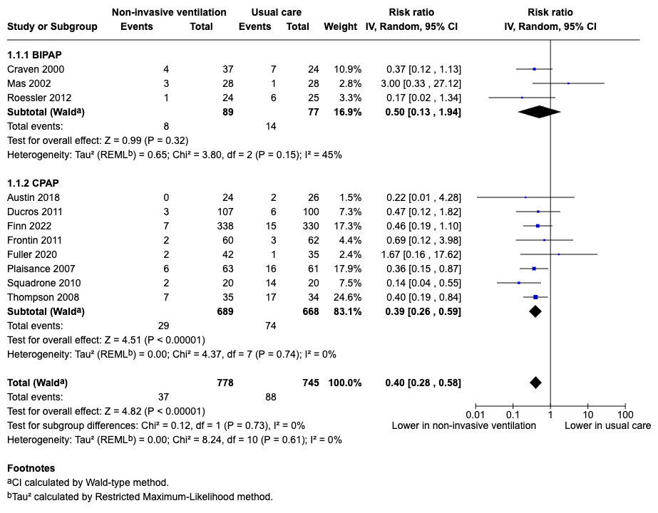
Supplementary Fig. 2. Subgroup analysis for primary outcome according to non-invasive ventilation modality. CI: confidence interval; IV: inverse variance; CPAP: continuous positive airway pressure; BIPAP: bilevel positive airway pressure.

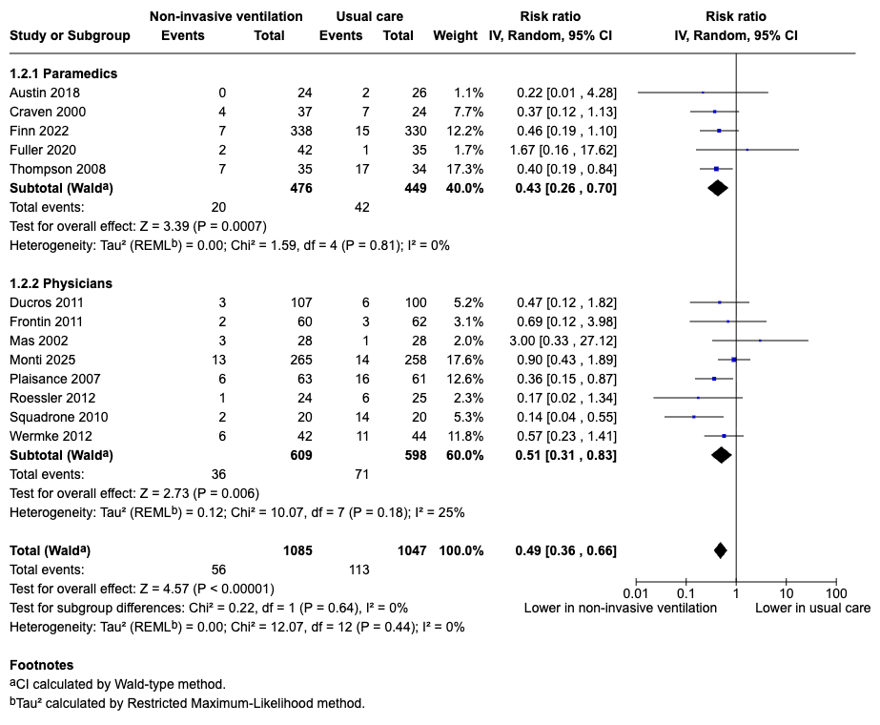
Supplementary Fig. 3. Subgroup analysis for primary outcome according to type of provider. CI: confidence interval; IV: inverse variance.

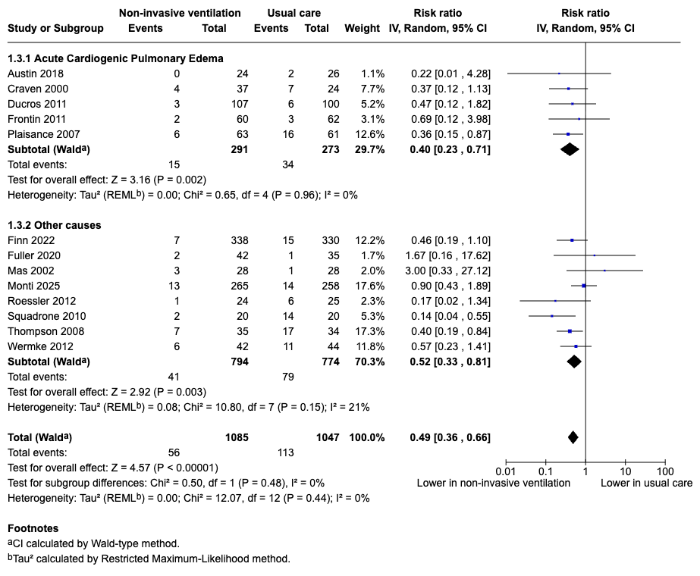
Supplementary Fig. 4. Subgroup analysis for primary outcome according to etiology of acute respiratory failure. CI: confidence interval; IV: inverse variance.

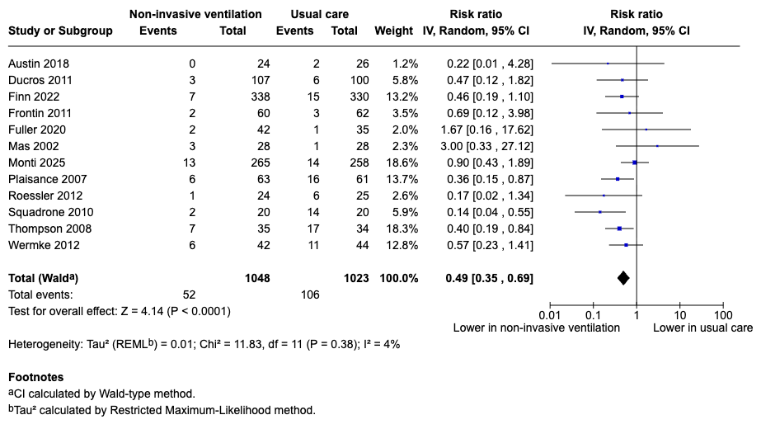
Supplementary Fig. 5. Sensitivity analysis for primary outcome excluding the quasi-randomized study (Craven 2000 [15]). CI: confidence interval; IV: inverse variance.

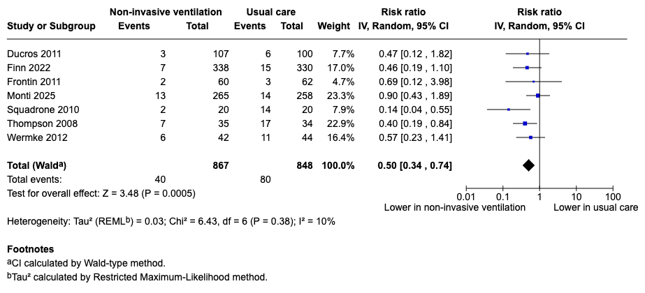
Supplementary Fig. 6. Sensitivity analysis for primary outcome excluding studies assessed at high risk of bias. CI: confidence interval; IV: inverse variance.

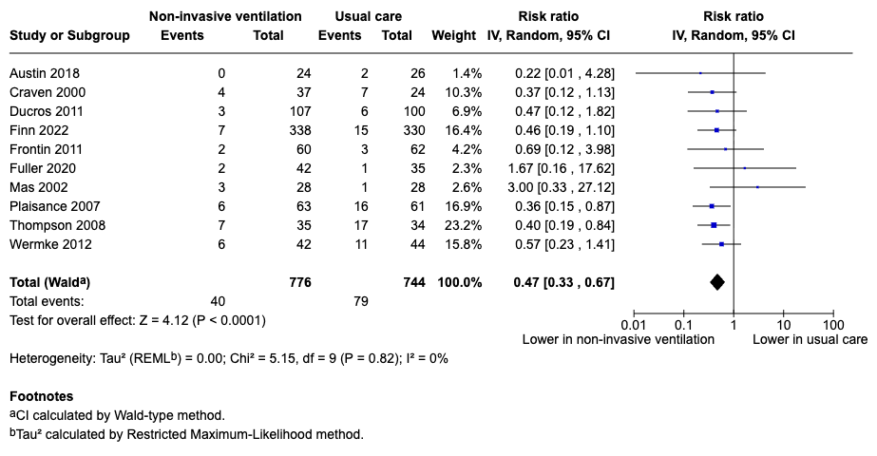
Supplementary Fig. 7. Sensitivity analysis for primary outcome restricted to studies using a face mask interface. CI: confidence interval; IV: inverse variance.

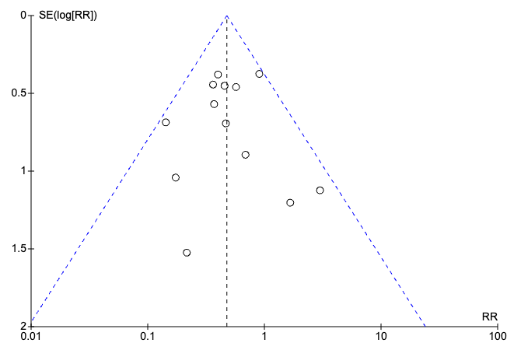
Supplementary Fig. 8. Funnel plot for primary outcome. RR: relative risk; SE: standard error.

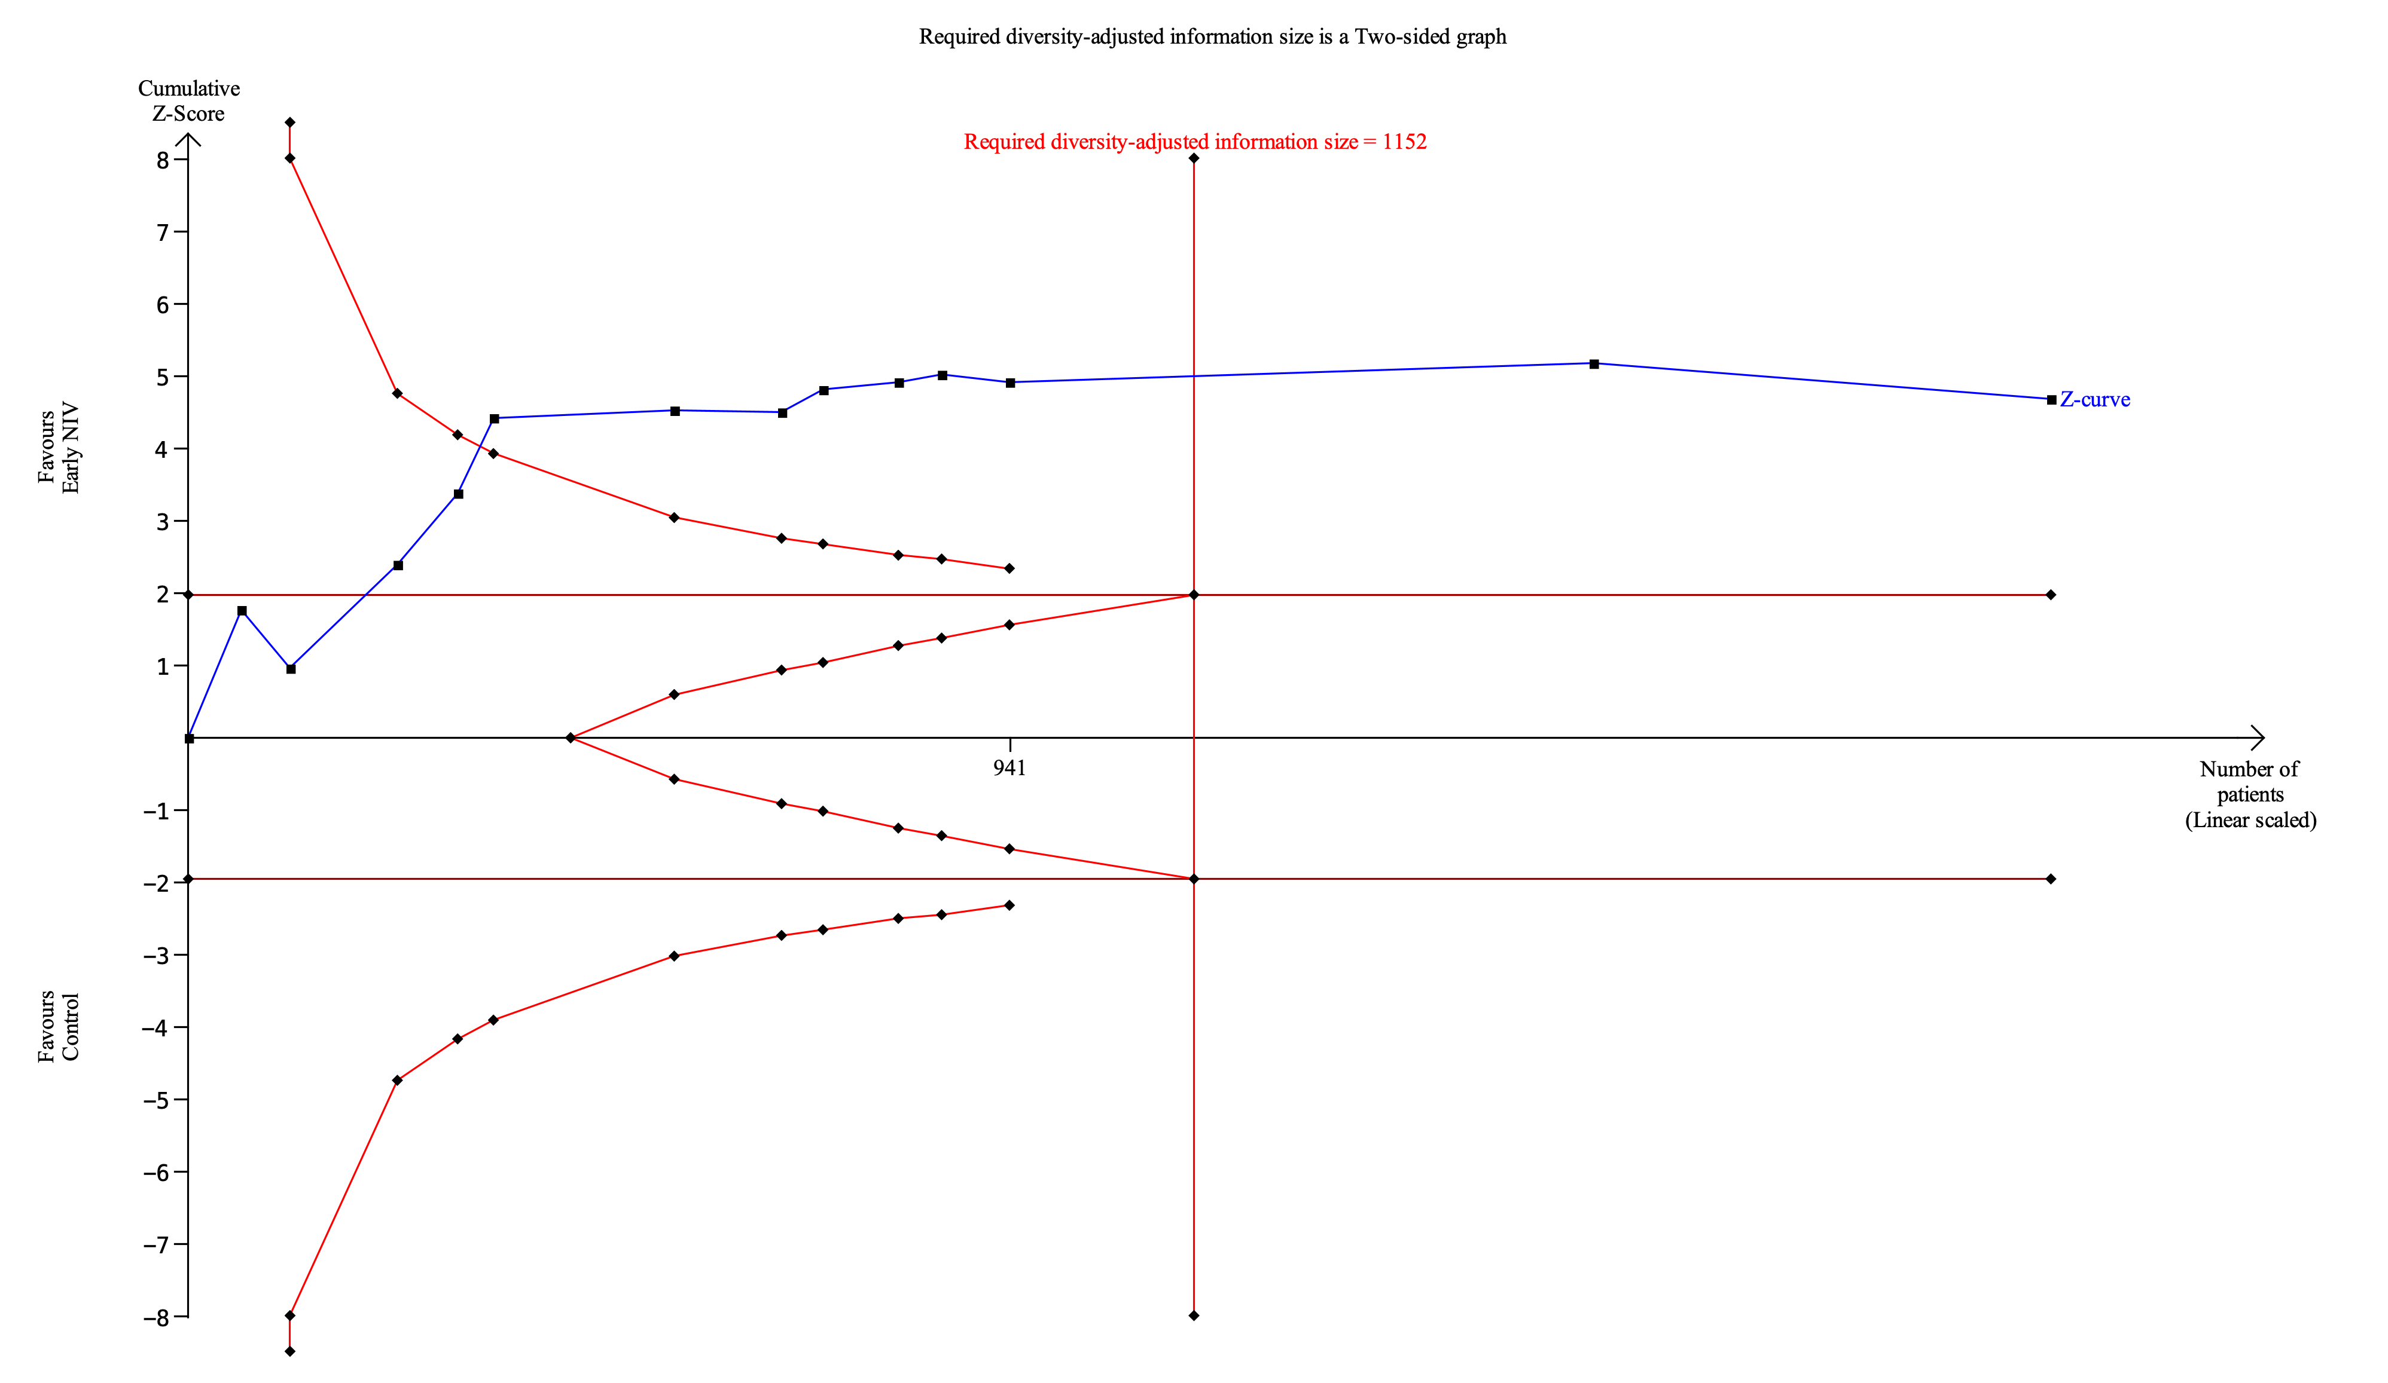
Supplementary Fig. 9. Trial sequential analysis.

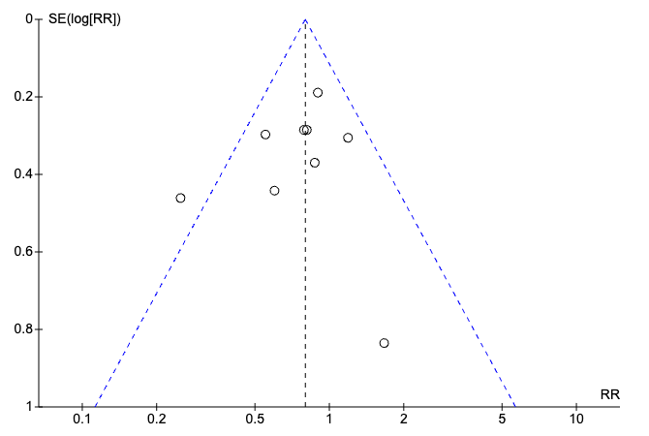
Supplementary Fig. 10. Funnel plot for intensive care unit admission rate. RR: relative risk; SE standard error.

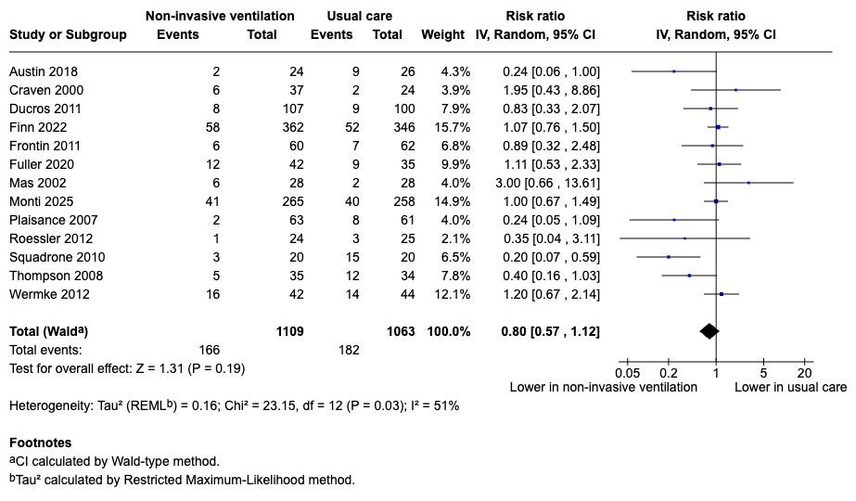
Supplementary Fig. 11. Effect of non-invasive ventilation on mortality at the longest follow-up available. CI: confidence interval; IV: inverse variance.

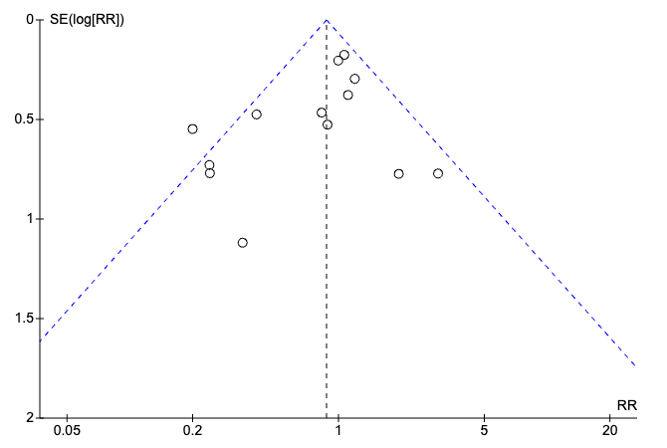
Supplementary Fig. 12. Funnel plot for mortality at the longest follow-up available. RR: relative risk; SE: standard error.

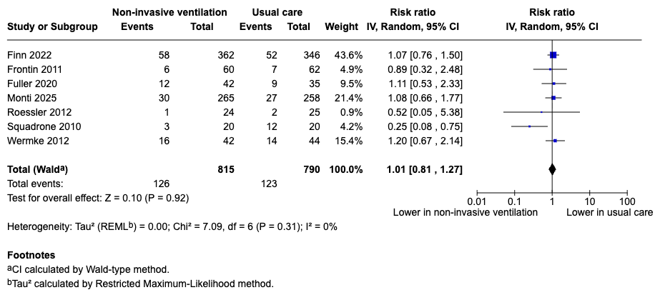
Supplementary Fig. 13. Effect of non-invasive ventilation on short-term mortality. CI: confidence interval; IV: inverse variance.

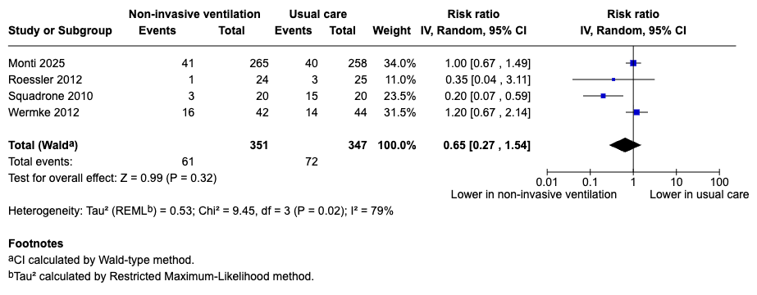
Supplementary Fig. 14. Effect of non-invasive ventilation on medium-term mortality. CI: confidence interval; IV: inverse variance.

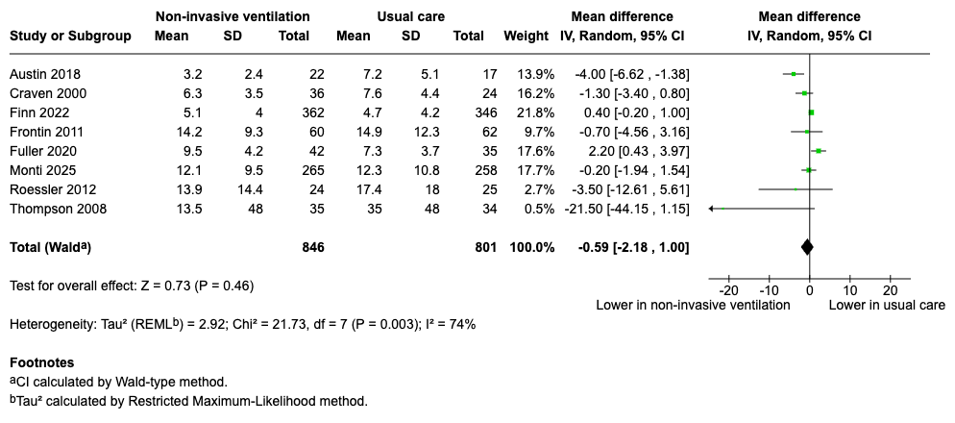
Supplementary Fig. 15. Effect of non-invasive ventilation on hospital length of stay. CI: confidence interval; IV: inverse variance; SD: standard deviation.

Supplementary References
[1] Dib JE, Matin SA, Luckert A. Prehospital use of continuous positive airway pressure for acute severe congestive heart failure. Journal of Emergency Medicine. 2012; 42: 553–558.
[2] Dunand A, Beysard N, Maudet L, Carron PN, Dami F, Piquilloud L, et al. Management of respiratory distress following prehospital implementation of noninvasive ventilation in a physician-staffed emergency medical service: a single-center retrospective study. Scandinavian Journal of Trauma, Resuscitation and Emergency Medicine. 2021; 29: 85.
[3] Gardtman M, Waagstein L, Karlsson T, Herlitz J. Has an intensified treatment in the ambulance of patients with acute severe left heart failure improved the outcome? European Journal of Emergency Medicine. 2000; 7: 15–24.
[4] Gartner BA, Fehlmann C, Suppan L, Niquille M, Rutschmann OT, Sarasin F. Effect of noninvasive ventilation on intubation risk in prehospital patients with acute cardiogenic pulmonary edema: a retrospective study. European Journal of Emergency Medicine. 2020; 27: 54–58.
[5] Garuti G, Bandiera G, Cattaruzza MS, Gelati L, Osborn JF, Toscani S, et al. Out-of-hospital helmet CPAP in acute respiratory failure reduces mortality: a study led by nurses. Monaldi Archives for Chest Disease. 2010; 73: 145–151.
[6] Hensel M, Strunden MS, Tank S, Gagelmann N, Wirtz S, Kerner T. Prehospital non-invasive ventilation in acute respiratory failure is justified even if the distance to hospital is short. The American Journal of Emergency Medicine. 2019; 37: 651–656.
[7] Hubble MW, Richards ME, Jarvis R, Millikan T, Young D. Effectiveness of prehospital continuous positive airway pressure in the management of acute pulmonary edema. Prehospital Emergency Care. 2006; 10: 430–439.
[8] Luiz T, Kumpch M, Grüttner J, Madler C, Viergutz T. Prehospital CPAP therapy by emergency physicians in patients with acute respiratory failure due to acute cardiogenic pulmonary edema or acutely exacerbated COPD. In Vivo. 2016; 30: 133–139.
[9] Pinczon J, Terzi N, Usseglio-Polatera P, Gheno G, Savary D, Debaty G, et al. Outcomes of patients treated with prehospital noninvasive ventilation: observational retrospective multicenter study in the Northern French Alps. Journal of Clinical Medicine. 2021; 10: 1359.
[10] Schmidbauer W, Ahlers O, Spies C, Dreyer A, Mager G, Kerner T. Early prehospital use of non-invasive ventilation improves acute respiratory failure in acute exacerbation of chronic obstructive pulmonary disease. Emergency Medicine Journal. 2011; 28: 626–627.
[11] Taylor DM, Bernard SA, Masci K, MacBean CE, Kennedy MP, Zalstein S. Prehospital noninvasive ventilation: a viable treatment option in the urban setting. Prehospital Emergency Care. 2008; 12: 42–45.
[12] Walter DC, Chan HK, Crowe RP, Osborn L, Jarvis J, Wang HE. Out-of-hospital, non-invasive, positive-pressure ventilation for acute dyspnea. Journal of the American College of Emergency Physicians Open. 2021; 2: e12542.
[13] Weitz G, Struck J, Zonak A, Balnus S, Perras B, Dodt C. Prehospital noninvasive pressure support ventilation for acute cardiogenic pulmonary edema. European Journal of Emergency Medicine. 2007; 14: 276–279.
[14] Willmore A, Dionne R, Maloney J, Ouston E, Stiell I. Effectiveness and safety of a prehospital program of continuous positive airway pressure (CPAP) in an urban setting. CJEM. 2015; 17: 609–616.
[15] Craven RA, Singletary N, Bosken L, Sewell E, Payne M, Lipsey R. Use of bilevel positive airway pressure in out-of-hospital patients. Academic Emergency Medicine. 2000; 7: 1065–1068.

